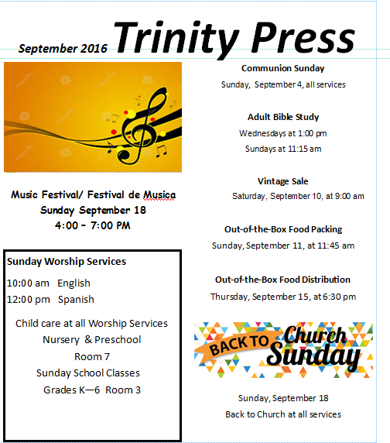

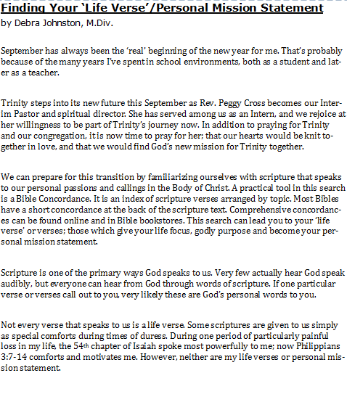

Finding Your ‘Life Verse’ - continued

A life verse is a call to action. My calling is to teach believers; particularly ensuring they are equipped with an understanding of scripture that helps them respond to life with faith, endurance and wisdom. I believe God has allowed me to experience some very dark times in my life, so I might know what Christians are up against in this world. These experiences have given me insight as to how I might better prepare other Christians.

My life’s calling verses are Ephesians 4:11-15:

“And He himself gave some to be apostles, some prophets, some evangelists, and some pastors and teachers, for the equipping of the saints for the work of ministry, for the edifying of the body of Christ till we all come to the unity of the faith and of the knowledge of the Son of God, perfected to the measure of the stature of the fullness of Christ; that we should no longer be children, tossed to and fro and carried about with every wind of doctrine…but speaking the truth in love, may grow up in all things into Him who is the head-Christ.”

Memorizing and meditating on scripture helps you refute discouragement or temptation to walk away from God’s purposes for your life. Think of Jesus’ temptation in the wilderness. Every temptation satan pressed upon him by twisting the meaning of scripture, Jesus was able to refute with his right understanding of scripture and his own calling.

This month why not make it your personal mission to find verses that speak to you; that urge you to action on behalf of Christ. As each of us becomes more aware of our personal calling in Christ, we are better able to see how God intends to build up Christ’s Body in this place to do the work of God in West Sacramento. dj

Deacons’ Summer Recap…

Trinity’s Board of Deacons has kept busy this summer. The members decided to NOT take a summer break as we usually do, so we have been meeting every month. Here’s what’s been happening…

- We’ve continued to provide a brief service for Riverbend residents on the 4th Sunday of each month. Robb Perrine has been providing the message this summer. We also sing hymns, visit with attendees, and someone might bring their dog along!
- Mailed another military box to an active-duty soldier.
- Added an usher to guide each row to the front of the sanctuary during Communion. This helps alleviate some congestion around the Communion table.
- Had a weenie roast/potluck before the July meeting. It was a great time cooking hot dogs over an open fire and having a wonderful time of fellowship before our regular monthly meeting.
- Continued to send cards to Trinity parish members—such as birthday, get well, anniversary, thinking of you, etc.

The Deacons are also thinking ahead to Fall projects…

- The Coat Project, held in conjunction with the November Out-of-the-Box distribution, will be held again. Save those coats and jackets!!!
- The Goody Bag Project—we again will provide much-needed personal items to folks without a home (early December).

And remember…
- Do you have a few minutes to spare on the afternoon of the 4th Sunday??? Anyone is invited to join us at a Riverbend Service on the 4th Sunday of each month at 2:00 pm. You do not have to be a Deacon! We invite you to join us in this worthwhile ministry.
- All Deacons and Elders are invited to participate in the Communion process—buying and preparing elements; serving Communion in the sanctuary and “to go” Communion for shut-ins.
- There will be openings on the Board of Deacons in early 2017. If you are a member of Trinity, you are eligible to be part of this important ministry. Please talk to a Deacon or an Elder!

Blessings from your Board of Deacons,

Morgan Schultz, Pat Fritchie, Rick Hawkins, Vi Taylor, Bev Meier, Ann Watson, Laura Singh, Glenda Dahms

About National Back-To-Church Sunday

Back-to-Church Sunday is a campaign strategically designed to help churches reach out and invite everyone to try church again. This powerful movement encourages church attendance by inspiring and empowering church members to invite their neighbors, friends and loved ones to a special Sunday service designed just for them.
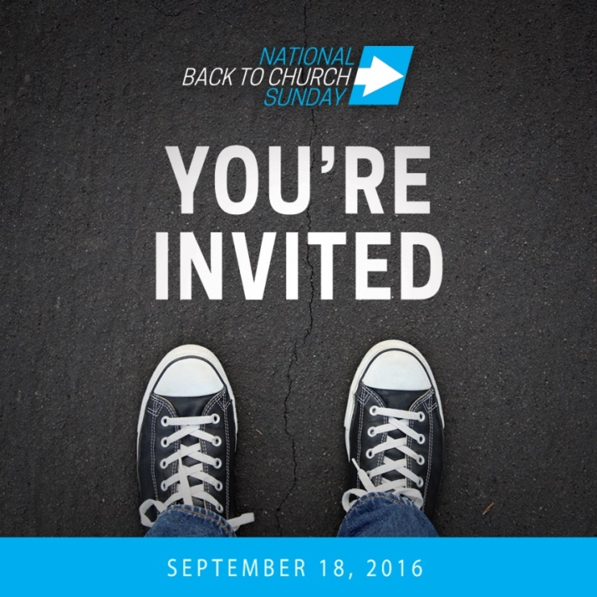

The School Bus Is Gone!

Thank you all for donating your dollars, school supplies, backpacks and prayers for another successful Backpack Project. We provided 70 fully-loaded backpacks to our church families and to the children of Riverbank Elementary School. Thank yous are extended to the following Trinity family and friends:

Gayle Andrade, Pat Terry, Joy Ann Merwin, Errol and Myrna Summy, Toni Sullivan, Judi Chiboucas, Terri Davis and Dave Bolach, Linda and Don Brooks, Joe and Nola Goeden, Sue Goodwin, Cliff and Ethel Hayes, Gloria and Will Curtis, Ken and Kathy Trott, Gary and Irene White, Pat Fritchie, Karen Metcalf, Vi Taylor, Ester Barnes, Jamie Knight, Al and Glenda Dahms, Karla Rasmussen, Sue Goodwin, Vi Taylor, The Schlunegger Family, Cathy and Dale Davis, Lori Custodio, Cora Hocker, Karen Sturdevant, others who donated anonymously, and myself, Jane Gentry.

I am extending special thanks to Hope Suson and her daughters Cassie, Stephi and Izzy, who packed 70 backpacks with me. I could not have done it without you!

Jane Gentry

Vintage/Gently-Used Sale –

Coming September 10th to Trinity

Trinity Threads Together (TTT) is planning a vintage/gently-used sale this fall instead of our craft sale. (We plan to have our craft sale in April of 2017.) So as you clean out your closets, cupboards and garages, be sure to save any unwanted items for Trinity's sale. All proceeds will go to the roof fund. Clean, gently-used clothing may still be donated by placing it in the barrel beneath the Welcome Center in the Narthex. Thanks for your help!

September Birthdays

Laura Singh 4

Hayden Crews 8

Ryan Dishman 10

Lori Schlunegger 10

Margaret Brinkhuis 12

Gabriel Kojima 12

Marilyn Allen 19

Robb Perrine 19

Carol Onalfo 20

Ethel Hayes 22

Jeanie Drummond 24

Toni Says …

It’s time to locate all those old or unused Christmas cards and donate them to “Out-of-the-Box”. We need 150-175 cards, one for each food bag for the December 15th distribution. Toni has again volunteered to sign all those cards! Thanks for your support.

Extra or unwanted 2017 calendars also make a great donation for Out-of-the- Box. Toni says a lot of our customers get confused over the exact date of the Out-of-the-Box distributions.

Coming Soon – The return of the Ladies Luncheon

The first Ladies Luncheon of the season is right around the corner. Our first luncheon will be Friday, September 8th, right here at Trinity.

We will have a meal together, chat, pray and get to know one another better. We are planning something special, so ladies please call the office to let us know you plan on attending. We ask that you bring a salad or side dish to share with others to complement the ‘something special’. We will provide dessert.

Ladies this is also a time to show off your place settings. To keep this event green, and keep the cost down, we ask all attending ladies to bring your own place setting (plate, bowl, cup and utensils). Of course, if you forget, we will have one for you!

Our special guest will be Karen Sturdevant from the Sacramento Presbytery. Karen is the Co-Moderator of Presbyterian Women and will talk to us about this ministry.

We look forward to seeing you!

September 18th Musica de Festival/Music Festival

Mark your calendars for Latin food, multi-cultural praise music and fun on Sunday, September 18th, outdoors at Trinity from 4:00 to 7:30 p.m. Trinity’s Spanish and English praise teams, along with special Bay Area guest artist, Carlos Crespo, will perform. Homemade tacos, nachos, Tijuana hotdogs, fruit and horchata will be available for purchase to help raise funds for Trinity’s roof project. In addition, a bounce house will be provided for children to enjoy at no cost.

September 18th is also ‘National Back to Church Sunday’, so invite your neighbors and friends and be prepared for a relaxing evening of music, food and fun.

Heifer Project Special Offering

Give a person a fish, feed them for a day; teach them to fish, feed them for a lifetime

On Back-to-Church Sunday, September 18th, Trinity Presbyterian Church is collecting a special offering to support the Sunday school children’s Heifer Project.

Over the past year, Sunday school children have been collecting weekly offerings for the Heifer Project. The children have collected over $263 to purchase animals to support the self-development of families throughout the world in need of help. Now the children are inviting adults in the church to join the effort.

Please come prepared on Sunday, September 18th, to hear about, and donate to, our Sunday school’s Heifer Project. If you are unable to be in church on the 18th, place your donation in the Heifer Offering box in the Narthex or, in an offering envelope in the offering plate any Sunday in September. Or you may give via the Church’s website.

Heifer International is a non-governmental, non-profit organization dedicated to helping families and communities become self-sufficient through animal husbandry. Heifer provides the animals – e.g., cows, chickens and goats -- as well as training to take care of them. The first offspring is given to a similarly-trained neighbor. These gifts have changed lives, clothed and fed families, and sent their children to school. Our donations make Heifer International’s work possible.

Peace and Global Witness Offering

On October 2, 2016, World Communion Sunday, Trinity will be collecting the Peace and Global Witness Offering. This offering’s purpose is to support the Presbyterian Church-USA’s Mission Agency’s work towards peace and reconciliation in our world. It seems to many Americans that we are in a time of division among peoples, whether racially, internationally or ideologically. The Church is called to promote healing and peace. This offering enables Presbyterians to do this in a meaningful way. Trinity retains 25 percent of this offering; another 25 percent is used at the Presbytery and Synod levels; and, 50 percent is used by the Presbyterian Church-USA to respond to injustice and violence through projects of collaboration, education and Christian witness. Watch for bulletin inserts for more information about the Peace and Global Witness Offering. You can explore the work of this offering at www.presbyterianmission.org/peace-global.

Latino Ministry Report

The Latino Ministry Leadership Team, along with Trinity’s Session and Presbytery are making strides towards finding a new pastor or pastora for the Latino Ministry. On Sunday, August 7th, a discernment meeting of the Latino congregation was held after worship. Pastora Miryam Osorio facilitated the luncheon meeting. Seventeen adults representing 11 families participated (one family participated via a separate phone interview). Four questions were discussed.

- Who are we?
- What are we called to do?
- Why are we here?
- What are the skills and gifts needed in our new pastor/a?

There was good participation by all who attended. The notes from the meeting have been compiled and are currently being finalized. On September 4th, the Latino Ministry Leadership Team will meet to review the results of the discernment meeting and work with Presbytery to finalize a pastor/a job description.

Choir Will Begin Soon

If God is calling you join the choir, come out for the first rehearsal of the season, Thursday, September 8, 2016, at 7:00 pm in the Sanctuary. It is not necessary that you read music, but if you do, that is a plus.

If you love to sing, this is the ministry for you. Please check the website for additional information.
www.trinitywestsac.org

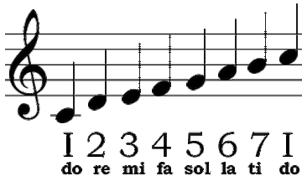

First Student Intern

This past summer Trinity was able to recruit our first student intern by signing an agreement with San Jose State University. Our first student intern was Graduate Student Kami Rasmussen. Kami has a BA in Communication Studies and is working on a Master’s Degree in the same subject. Her background includes classes in Intercultural Communication and Media Effects.

Kami completed over 200 hours of work, with an emphasis on social media, to complete her internship objectives. Her internship objectives included creating a user-friendly website for Trinity. You may have noticed our website has been updated, and it now has a search engine!

Kami stressed the importance of using social media as an interface between Trinity and young parents searching for family-friendly environments. You may have noticed her taking photos at events, meetings and church services. She used the photos to promote events before they happened, promote them while they were happening, and promote Trinity after the event.

Thank you Kami!

We look forward to recruiting our next student intern. If you are interested in applying, please call the Office Administrator at (916) 371-5875.

Intern Kami Rasmussen

