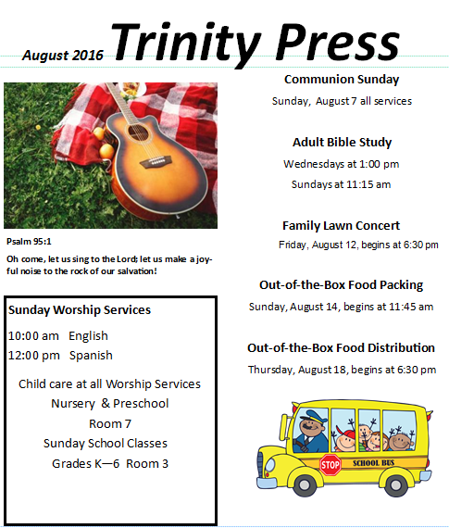
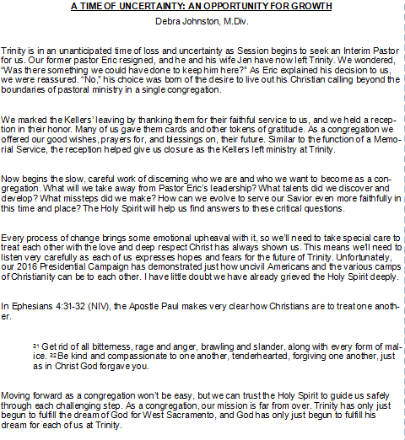

Next Steps

Our Clerk of Session, Cora Hocker, addressed the congregation Sunday, July 17th, 2016. She assured us Session is working towards finding a new pastor, and that we will continue to have service each Sunday as we always have. First, we will have a couple of elders preaching, then some pastors from the Sacramento Presbytery, and then we should have an interim pastor ready to preach and lead us as we begin the search process for a new pastor.
The first elder to preach was Sue Goodwin, and she was on fire delivering a very powerful message titled “Choosing the GOOD news!” Sue reminded us that God is constant even when we aren’t. She also reminded us that we should make an intentional effort to spend time reading scripture and praying to God.
Elder Robb Perrine will preach Sunday, July 24th, followed by a series of pastors from the Sacramento Presbytery. We hope you’ll come out to hear the unique messages each of the pastors has to share. We also hope you pray for our church as we begin the process of selecting an interim pastor and then a new pastor.

Presbyterian Church Organization

The Presbyterian Church (U.S.A.) has over 10,000 congregations which are organized into 172 presbyteries (district governing bodies) and 16 synods (regional governing bodies).
Trinity belongs to the Synod of the Pacific, currently made up of 11 Presbyteries, 464 Churches, 20 new Church developments and 114,210 members. Its primary role is to be a Mission Support Synod. This is accomplished through providing financial and administrative support services to its presbyteries and churches. The services currently offered are:
Administrative and Personnel Services
Financial Investment and Loan Opportunities
Health & Benefit Opportunities
Mission Treasury Service Receiving Site
Multi-Presbytery gatherings and workshops
Ecclesiastical functions

The 11 Presbyteries include the Presbytery of Sacramento, to which Trinity belongs. The Presbytery of Sacramento’s primary role is to:
Build bridges and connect deeply with each other as we worship and serve together in the name of Christ;
Nurture mature leaders and healthy congregations to proclaim the Gospel to all people;
Entrust ourselves and each other to the goodness and sovereignty of God as we live into the hope of God's Realm.

Trinity is one church of Sacramento Presbytery. Trinity has a leadership team that includes Elders and Pastors called Session. Session’s role is to:
Carry out the business of the church by delegating authority to various committees;
Act as the Trustees of the church;
Approve all church activities; and
Provide guidance to the church Deacons, who provide care and comfort to the church congregation.

Back By Popular Demand – Richard March (Yay!)

Trinity’s annual Lawn Concert will be held Friday, August 12th, from 6:30 to 8:00 pm. It will be on Trinity’s front lawn with the featured musician Richard March. It has been a few years since Richard was able to be here, and we are happy to welcome him back. He recently returned from a two-and-a-half year Peace Corps assignment in Ethiopia.

We are so looking forward to hearing Richard again as he entertains us with his Americana and folk-style music. We’re asking Trinity folks to bring desserts to share with our invited guests (neighbors, family, friends, coworkers, etc.). We ask that your desserts be ready to serve and easy to eat. Suggested desserts include cookies, brownies and cupcakes. Trinity’s Mission and Outreach Team will provide ice cold water!

Toni’s New Thing!

For Out-of-the-Box (OOTB) Toni is giving out small bags of dry dog food; 10 baggies to start.
If you wish to donate a bag of dog food (or baggies) in honor of your pet, Toni will be able to supply and expand this new part of OOTB.
See Jane in the church office or leave clearly marked donations in the donation tub in the Lounge. Thanks for your support!
Toni got this idea from Ken and Kathy Trott, who donated a big bag of dog food (all bagged up and ready to pass out) when they lost their dog Sushi.

Toni’s New Thing Rebuttal!

Wait a minute? What about our Feline friends? Do they need to eat? Yes! Do they deserve to eat…depends on who you talk to, but I am going to say yes. Then again, they can be very finicky or independent and may not like the food you want to give them.
I decided to try various foods on Maybe (a feline), and she gave me a look that could have said any of the responses listed below:
  - Are you kidding me?!
  - Would you eat that? … I didn’t think so.
  - You expect me to eat that? Are you serious?
  - Not really hungry.
  - Not feeling it; literally, not touching it!
  - I would rather eat anything else!

So there you have it. On second thought, great ministry Toni!

August Birthdays
Joy Ann Merwin 4
Myrna Summy 6
Kelly Custodio 11
Nikki Custodio 11
Elizabeth Cypress 14
Job Gil 15
Mallory Cypress 16
Kyle Richardson 19
Jeffry Grexton 28
Maxine Harper 31

Gently-Used Sale – Coming September 10th to Trinity

Trinity Threads Together (TTT) is planning a yard/garage sale this fall instead of our craft sale. (We plan to have our craft sale in April of 2017.) So as you clean out your closets, cupboards and garages, be sure to save any unwanted items for Trinity's sale. All proceeds will go to the roof fund. Clean, gently-used clothing may still be donated by placing it in the barrel beneath the Welcome Center in the Narthex. Thanks for your help!

